**Python Assignment**

**Question 1: -**

**Write a program that takes a string as input and counts the frequency of each word in the string, there might be repeated characters in the string. Your task is to find the highest frequency and returns the length of the highest-frequency word.**

**Note - You** **have to write at least 2 additional test cases in which your program will run successfully and provide an explanation for the same.**

**Example input - string = “write** **write** **write all the number from** **from** **from 1 to 100”**

**Example output - 5**

**Explanation - From the given string we can note that the most frequent words are “write” and “from” and the maximum value of both the values is “write” and its corresponding length is 5**

**Answer 1 Python: -** [**https://github.com/kamleshp95/Placement-Assignment_Ramchandra_Padwal/blob/main/Interview%20Based%20Assignment/Python/01.Question_01.ipynb**](https://github.com/kamleshp95/Placement-Assignment_Ramchandra_Padwal/blob/main/Interview%20Based%20Assignment/Python/01.Question_01.ipynb)

**Question 2: -**

Consider a string to be valid if all characters of the string appear the same number of times. It is also valid if

he can remove just one character at the index in the string, and the remaining characters will occur the same

number of times. Given a string, determine if it is valid. If so, return YES , otherwise return NO .

Note - You have to write at least 2 additional test cases in which your program will run successfully and provide

an explanation for the same.

Example input 1 - s = “abc”. This is a valid string because frequencies are { “a”: 1, “b”: 1, “c”: 1 }

Example output 1- YES

Example input 2 - s “abcc”. This string is not valid as we can remove only 1 occurrence of “c”. That leaves

character frequencies of { “a”: 1, “b”: 1 , “c”: 2 }

Example output 2 – NO

**Answer 2 Python: -** [**https://github.com/kamleshp95/Placement-Assignment_Ramchandra_Padwal/blob/main/Interview%20Based%20Assignment/Python/02.Question_02.ipynb**](https://github.com/kamleshp95/Placement-Assignment_Ramchandra_Padwal/blob/main/Interview%20Based%20Assignment/Python/02.Question_02.ipynb)

**Question 3: -**

Write a program, which would download the data from the provided link, and then read the data and convert

that into properly structured data and return it in Excel format.

Note - Write comments wherever necessary explaining the code written.

Link - <https://raw.githubusercontent.com/Biuni/PokemonGO-Pokedex/master/pokedex.json>

Data Attributes - id: Identification Number - int num: Number of the

● Pokémon in the official Pokédex - int name: Pokémon name -

● string img: URL to an image of this Pokémon - string type:

● Pokémon type -string height: Pokémon height - float

● weight: Pokémon weight - float candy: type of candy used to evolve Pokémon or

given

● when transferred - string candy_count: the amount of candies required to evolve

- int

● egg: Number of kilometers to travel to hatch the egg - float spawn_chance:

● Percentage of spawn chance (NEW) - float avg_spawns: Number of this

pokemon on 10.000 spawns (NEW) - int

● spawn_time: Spawns most active at the time on this field. Spawn times are the same for all

time zones and are expressed in local time. (NEW) - “minutes: seconds” multipliers:

Multiplier of Combat Power (CP) for calculating the CP after evolution See below - list of int

weakness: Types of

● Pokémon this Pokémon is weak to - list of strings next_evolution: Number and Name of

successive evolutions of Pokémon - list of dict prev_evolution: Number and Name of previous

evolutions of Pokémon - - list of dict

**Answer 3 Python: -** <https://github.com/kamleshp95/Placement-Assignment_Ramchandra_Padwal/blob/main/Interview%20Based%20Assignment/Python/03.Question_03.ipynb>

**Question 4 -**

Write a program to download the data from the link given below and then read the data and convert the into

the proper structure and return it as a CSV file.

Link - <https://data.nasa.gov/resource/y77d-th95.json>

Note - Write code comments wherever needed for code understanding.

Sample Data -

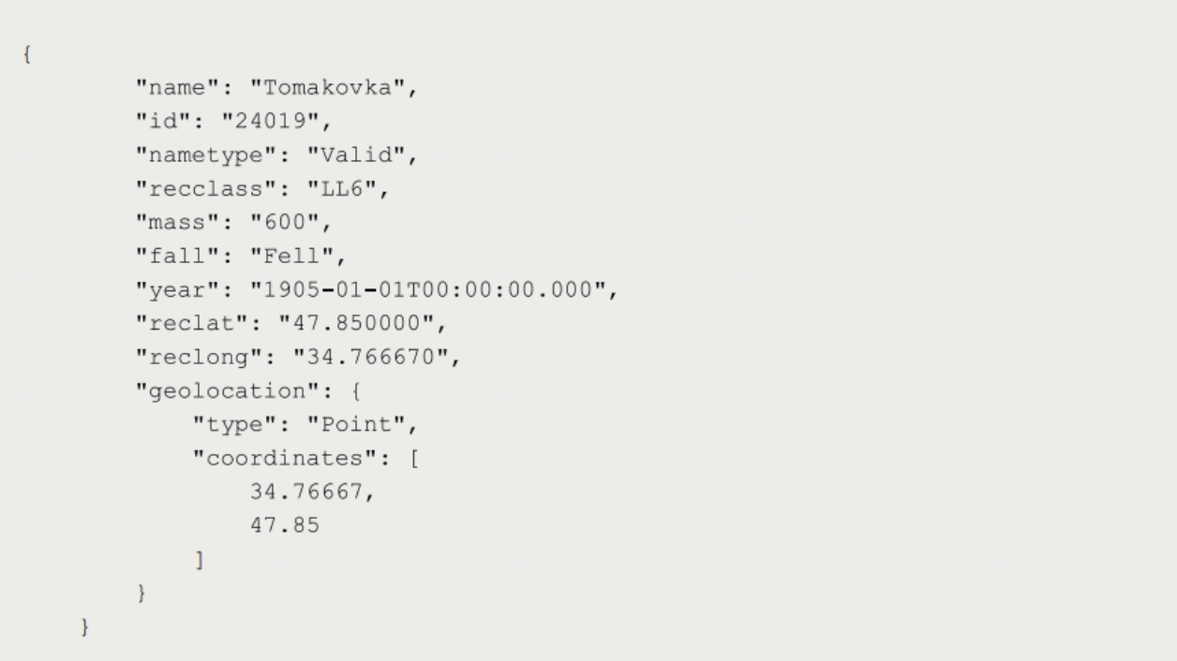

Excepted Output Data Attributes

● Name of Earth Meteorite - string id - ID of Earth

● Meteorite - int nametype - string recclass - string

● mass - Mass of Earth Meteorite - float year - Year at which Earth

● Meteorite was hit - datetime format reclat - float recclong - float

● point coordinates - list of int

**Answer 4 Python: -** [**https://github.com/kamleshp95/Placement-Assignment_Ramchandra_Padwal/blob/main/Interview%20Based%20Assignment/Python/04.Question_04.ipynb**](https://github.com/kamleshp95/Placement-Assignment_Ramchandra_Padwal/blob/main/Interview%20Based%20Assignment/Python/04.Question_04.ipynb)

**Question 5 -**

**Write a program to download the data from the given API link and then extract the following data with**

**proper formatting**

**Link -** [**http://api.tvmaze.com/singlesearch/shows?q=westworld&embed=episodes**](http://api.tvmaze.com/singlesearch/shows?q=westworld&embed=episodes)

**Note - Write proper code comments wherever needed for the code understanding**

**Sample Data -**

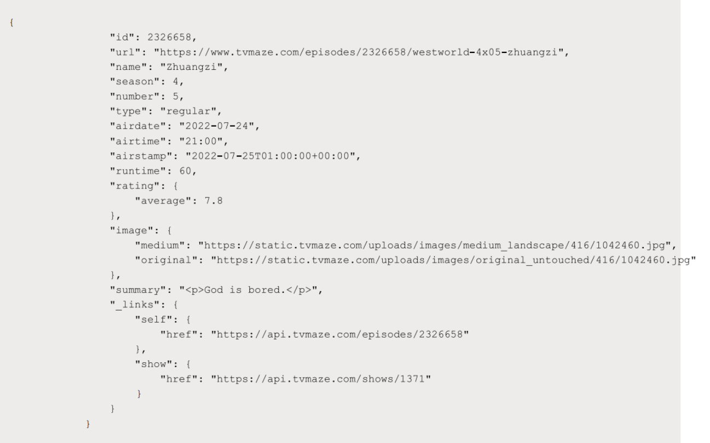

Excepted Output Data Attributes -

● id - int url - string

● name - string season

● - int number - int

● type - string airdate -

● date format airtime -

● 12-hour time format

● runtime - float

● average rating – float

● summary - string

● without html tags

● medium image link - string

● Original image link – string

**Answer 5 Python: -** [**https://github.com/kamleshp95/Placement-Assignment_Ramchandra_Padwal/blob/main/Interview%20Based%20Assignment/Python/05.Question_05.ipynb**](https://github.com/kamleshp95/Placement-Assignment_Ramchandra_Padwal/blob/main/Interview%20Based%20Assignment/Python/05.Question_05.ipynb)

**Question 6 -**

**Using the data from Question 3, write code to analyze the data and answer the following questions Note 1.**

**Draw plots to demonstrate the analysis for the following questions for better visualizations.**

**2. Write code comments wherever required for code understanding**

**Insights to be drawn -**

**● Get all Pokemons whose spawn rate is less than 5%**

**● Get all Pokemons that have less than 4 weaknesses**

**● Get all Pokemons that have no multipliers at all**

**● Get all Pokemons that do not have more than 2 evolutions**

**● Get all Pokemons whose spawn time is less than 300 seconds.**

**Note - spawn time format is "05:32”, so assume “minute: second” format and perform the analysis.**

**● Get all Pokemon who have more than two types of capabilities**

**Answer 6 Python: -** [**https://github.com/kamleshp95/Placement-Assignment_Ramchandra_Padwal/blob/main/Interview%20Based%20Assignment/Python/06.Question_06.ipynb**](https://github.com/kamleshp95/Placement-Assignment_Ramchandra_Padwal/blob/main/Interview%20Based%20Assignment/Python/06.Question_06.ipynb)

**Question 7 -**

**Using the data from Question 4, write code to analyze the data and answer the following questions Note -**

**1. Draw plots to demonstrate the analysis for the following questions for better visualizations**

**2. Write code comments wherever required for code understanding**

**Insights to be drawn -**

**● Get all the Earth meteorites that fell before the year 2000**

**● Get all the earth meteorites co-ordinates who fell before the year 1970**

**● Assuming that the mass of the earth meteorites was in kg, get all those whose mass was more**

**than 10000kg**

**Answer 7 Python: -** [**https://github.com/kamleshp95/Placement-Assignment_Ramchandra_Padwal/blob/main/Interview%20Based%20Assignment/Python/07.Question_07.ipynb**](https://github.com/kamleshp95/Placement-Assignment_Ramchandra_Padwal/blob/main/Interview%20Based%20Assignment/Python/07.Question_07.ipynb)

**Question 8 -**

**Using the data from Question 5, write code the analyze the data and answer the following questions Note -**

**1. Draw plots to demonstrate the analysis for the following questions and better visualizations**

**2. Write code comments wherever required for code understanding**

**Insights to be drawn -**

**● Get all the overall ratings for each season and using plots compare the ratings for all the**

**seasons, like season 1 ratings, season 2, and so on.**

**● Get all the episode names, whose average rating is more than 8 for every season**

**● Get all the episode names that aired before May 2019**

**● Get the episode name from each season with the highest and lowest rating**

**● Get the summary for the most popular ( ratings ) episode in every season**

**Answer 8 Python: -** [**https://github.com/kamleshp95/Placement-Assignment_Ramchandra_Padwal/blob/main/Interview%20Based%20Assignment/Python/08.Question_08.ipynb**](https://github.com/kamleshp95/Placement-Assignment_Ramchandra_Padwal/blob/main/Interview%20Based%20Assignment/Python/08.Question_08.ipynb)

**Question 9 -**

**Write a program to read the data from the following link, perform data analysis and answer the following**

**questions**

**Note -**

**1. Write code comments wherever required for code understanding**

**Link - https://data.wa.gov/api/views/f6w7-q2d2/rows.csv?accessType=DOWNLOAD**

**Insights to be drawn -**

**● Get all the cars and their types that do not qualify for clean alternative fuel vehicle**

**● Get all TESLA cars with the model year, and model type made in Bothell City.**

**● Get all the cars that have an electric range of more than 100, and were made after**

**2015**

**● Draw plots to show the distribution between city and electric vehicle type**

**Answer 9 Python: -** [**https://github.com/kamleshp95/Placement-Assignment_Ramchandra_Padwal/blob/main/Interview%20Based%20Assignment/Python/09.Question_09.ipynb**](https://github.com/kamleshp95/Placement-Assignment_Ramchandra_Padwal/blob/main/Interview%20Based%20Assignment/Python/09.Question_09.ipynb)

**Question 10 -**

**Write a program to count the number of verbs, nouns, pronouns, and adjectives in a given particular phrase or**

**paragraph, and return their respective count as a dictionary.**

**Note -**

**1. Write code comments wherever required for code**

**2. You have to write at least 2 additional test cases in which your program will run successfully and provide**

**an explanation for the same.**

**Example Output -**

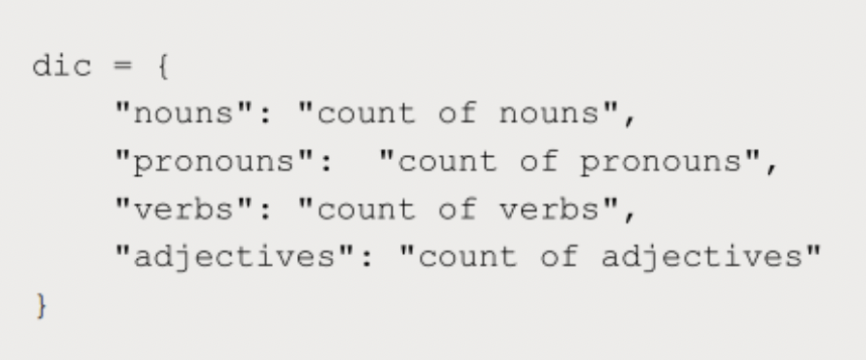

**Answer 10 Python: -** [**https://github.com/kamleshp95/Placement-Assignment_Ramchandra_Padwal/blob/main/Interview%20Based%20Assignment/Python/10.Question_10.ipynb**](https://github.com/kamleshp95/Placement-Assignment_Ramchandra_Padwal/blob/main/Interview%20Based%20Assignment/Python/10.Question_10.ipynb)